**Zomato Restaurants Analysis**

**Objective Questions**:

1. What is the total no. of tables present in the data?

***Answer***

There are 2 tables in the data provided. One is the raw data containing the details of the restaurants and the other is sort of a helper table that maps country codes and names.

1. What is the total no. of attributes present in the data?

***Answer***

In table 1, there are 20 attributes present and in table 2 there are 2 attributes present. Details of these attributes are attached with Question 3.

1. How many categorical columns are there in the data? [Search about categorical and continuous data, and try to answer this question]

***Answer***

Data can be of Qualitative(Categorical) or Quantitative(Numeric).

* Categorical data represents labels or categories that classify data without any numeric meaning. The subtypes include:
  + Nominal: Where there is no inherent order
  + Ordinal: Where a clear logical order is present
* Quantitative data denotes numeric values that support mathematical operations. There are 2 subtypes:
  + Continuous: Data that can take any values within a range.
  + Discrete: Data that takes distinct, countable values.

The data provided consists of 15 categorical columns across both the tables. The detailed summary of the types of attributes is attached in the image below.

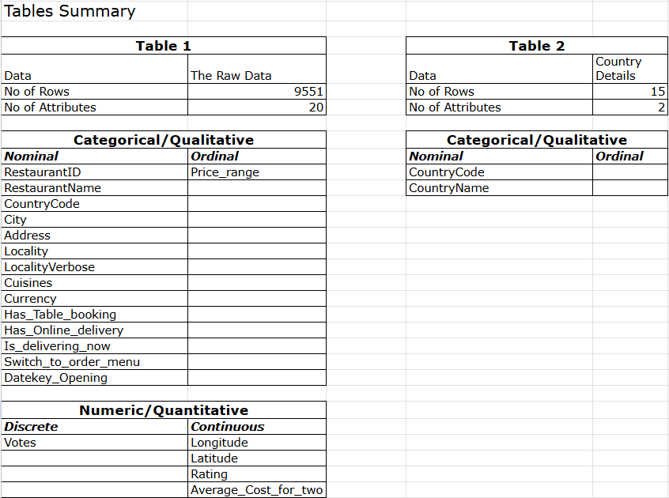

1. The data consists of some inconsistent and missing values so ensure that the data used for further analysis is cleaned.

***Answer***

The data was cleaned and transferred to a new sheet named Modified_Raw Data which was used for further analysis. The data cleaning process included:

* There were 498 rows with Latitude and Longitude values as 0. All these values were changed to “Missing” and an additional column named Location_valid was added to identify these. This helper column was filled with values as No whenever values in Latitude and Longitude were Missing and Yes otherwise.
* The Cuisine column had blank values in 9 data points. This again was replaced with “Missing”.
* Also added an additional Cuisne_count column to extract the total no. of cuisines offered by restaurants that had a multi-cuisine menu.
* The avg_cost_for_two column also had 0 for 18 data points which didn’t seem accurate. So added a helper column named valid_price column inorder to keep a watch for this during analysis.
* Switch_to_order_menu column had only No as values and hence didn’t provide much insight or information. Hence removed the column
* Added an year_opening column to extract the year of opening from the date_key opening attribute which was not given in date format

1. Using the LookUp functions, fill up the countries in the original data using the country code.

***Answer***

XLOOKUP was used for fetching the country name based on the country code that was common across tables.

1. Create a table to represent the number of restaurants opened in each country.

***Answer***

This was done using both pivot tables as well as functions. In the pivot table, country was added in rows and COUNT of restaurantID was added in values. Without pivot tables, initially UNIQUE() was used to fetch all the unique country names. Following that COUNTIF() was used to extract the no. of times the particular Country name occurred in the Country name column.

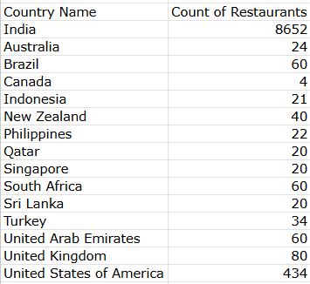

1. Also, the management wants to look at the number of restaurants opened each year, so provide them with something here.

***Answer***

A pivot table was created by adding year_opening in row and COUNT of RestaurantID in values. And a bar chart was created from this pivot table for the visual representation.

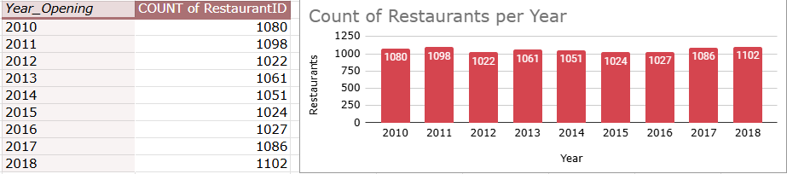

1. What is the total number of restaurants in India in the price range of 4?

***Answer***

A pivot chart was used to identify this. According to the chart we can see that there are a total of 388 restaurants in India that are in the price range 4.

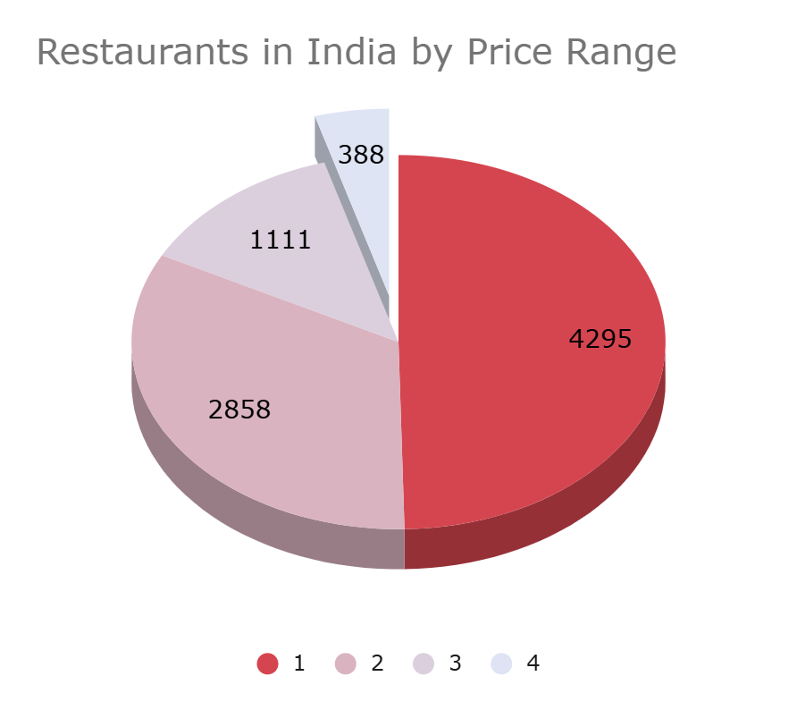

1. What is the average number of voters for the restaurants in each country according to the data?

***Answer***

This can be obtained by creating a pivot table with Country name in row and AVERAGE of votes in values. But on analysis it was observed that almost 33% of the data points had less than 10 votes and 70% of restaurants had less than 100 votes. So to avoid these numbers from affecting the average we can add a FILTER to the table as Votes>10, or Votes>100. The snippet of avg voters per country without any filtered applied is attached below.

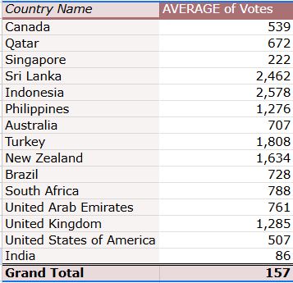

1. Calculate the average rating for all the restaurants that have price_range < 4 and provide online delivery. Use only the “IF” function, Logical Operators, and Aggregation functions to solve this problem. **[Note: Don’t use Conditional aggregation in this question.]**

***Answer***

ARRAYFORMULA was used to extract the required information without using Conditional Aggregation. The syntax of formula used is:

**=ARRAYFORMULA(average(IF((Onlined_delivery="Yes")*(Price_range<4),(Rating))))**

This gave the avg. ratings for the restaurants satisfying the given conditions as 3.2.

The column names in the formula are given directly for easy readability.

1. Using Conditional formatting highlight the rows of restaurants that are located in the countries or cities that you’ve suggested to the management for opening new restaurants.

***Answer***

To visually emphasize the restaurants located in the countries recommended for expansion, conditional formatting was applied to the dataset. The countries identified for expansion, **Indonesia, Philippines, United Kingdom, South Africa, and United Arab Emirates** correspond to specific Country code values in the dataset: **94, 162, 189, 214, and 215**, respectively.

To highlight these entries, a custom formula was used in conditional formatting:

**=OR($C2=94,$C2=162,$C2=189,$C2=214,$C2=215)**

This formula was applied to the entire data range, where column **C** contains the Country code. When this condition is met, the corresponding row is highlighted, making it easy to visually track and analyze restaurants within the targeted expansion markets. This step enhances both readability and analytical focus within the dashboard and raw data views.

1. Create a new customized price column that consists of the abbreviation/symbol of the currency along with the Average_cost_for_two value. [Use string operations to do this task]

***Answer***

The formula used is as follows:

**=CONCATENATE(LEFT(RIGHT(Q2,LEN(Q2)-FIND("(",Q2)),LEN(RIGHT(Q2,LEN(Q2)-FIND("(",Q2)))-1)," ",W2)**

Here Q represents the currency column and W represents the avg_cost_for_two column.

Basically we have extracted the currency symbol which was given at the end of the currency field enclosed in () using LEFT(), RIGH(), FIND() and LEN() string functions. And after that CONCATENATE() was used to attach the symbol and avg. cost value.

1. How can you create an array formula in Excel or Google Sheets to count the number of restaurants listed that do not offer online delivery, are in the lowest price range, and have an average cost for two people less than or equal to 250 Indian Rupees?

***Anwer***

This again is a direct application of ARRAYFORMULA. The formula used is as follows:

**=arrayformula(SUM((Online_delivery="No")*(Price_range=min(unique(Price_range)))*(avg_cost_for_two in INR<=250)))**

And it turned out that 1694 restaurants out of the total 9551 data points belong to all the above mentioned criterias.

**Subjective Questions**

1. Suggest a few countries where the team can open newer restaurants with lesser competition. Which visualization/technique will you use here to justify the suggestions?

***Answer***

* **Reference**
  + **Image 1** - Bar chart representing countries on x-axis and the no. of restaurants on the y-axis.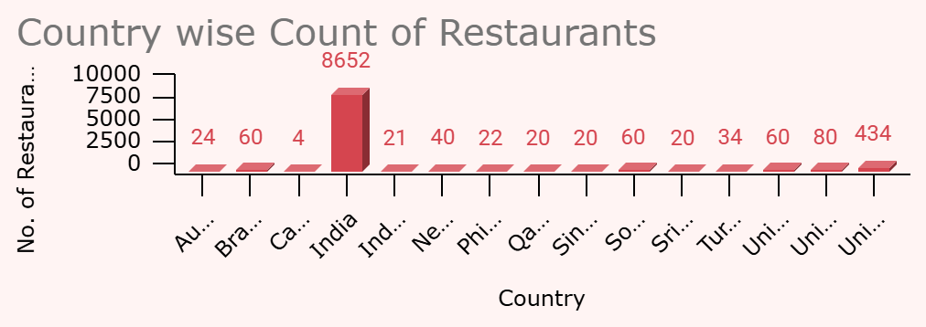
  + **Image 2** - Pivot table showing country wise no. of restaurants, median and average votes and median and average ratings for the two filters namely votes > 10 and votes > 100.

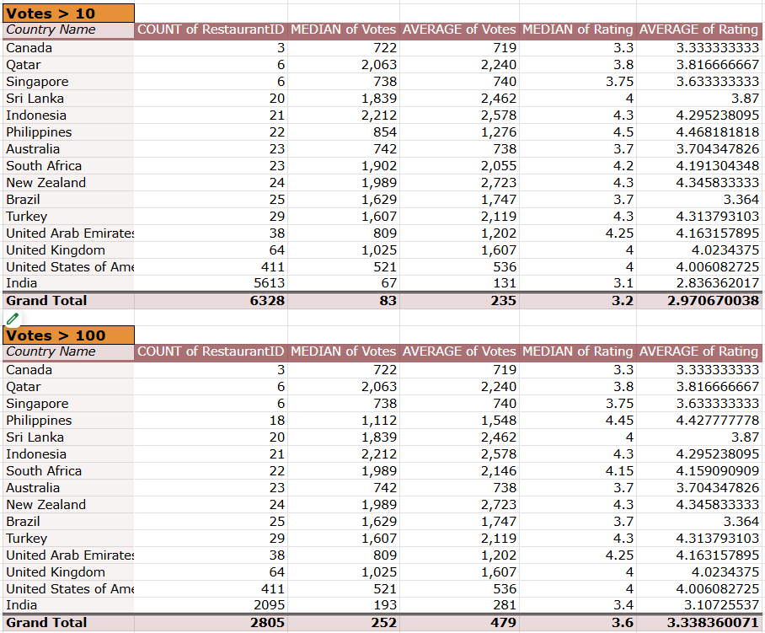

* + **Image 3** - Selection of the countries based on the segmentation logic. The green highlighted cells in each column represent the countries that are selected based on the criteria. The countries with all columns selected are shortlisted and highlighted in yellow.

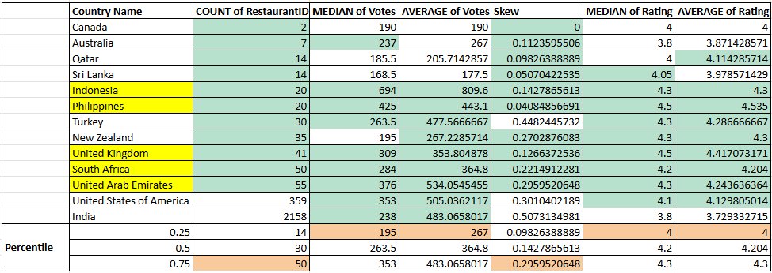

* + **Image 4** - Rating the countries based on the segmentation logic. The countries with Low count, High votes and High Rating are selected and highlighted in yellow.
  + 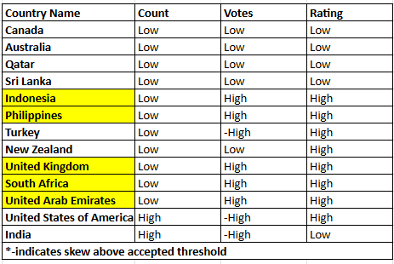
* **Approach** 
  + A bar chart was created to visualize the number of restaurants in each country(**Image 1**).
  + Further segmentation was carried out using three key metrics: Restaurant Count (to estimate competition), Votes (to assess engagement), and Rating (to understand customer satisfaction).
  + Average and Median of votes and rating was analysed in order to understand if the data has a general spread or if it's skewed.
  + The analysis included two vote-based filters: Votes > 10 and Votes > 100 to eliminate under-reviewed listings(**Image 2**).
  + A liberal percentile-based segmentation framework was used to categorize countries, based on(**Image 3, Image 4**):
    - No. of restaurants <= 55 (75th percentile is 50) considered low inorder to include even moderately represented countries.
    - Countries with votes > 25th percentile considered as High engagement.
    - Skewness in votes <= 75th percentile is considered Low.
    - Countries with rating > 25th percentile tagged as High Rating
* **Insights** 
  + The dataset consists of details regarding 9551 restaurants. Out of this only 6328(~66%) restaurants have received more than 10 votes indicating that almost one third of the restaurants have very minimal customer engagement. And further analysis shows that only 2805(~29%) restaurants have votes > 100.
  + Focusing on these restaurants can provide a more clearer picture of genuinely well received establishments.
  + **Brazil, Singapore** don't have even a single restaurant with significant engagement. Might be due to new or inactive listings, lack of market maturity or even lack of feedback data. Hence ignored for shortlisting.
  + **Canada, Australia, Qatar** and **Sri Lanka** show weak engagement and satisfaction in a small market. Market seems very inactive and hence it’s risky to enter.
  + Despite strong votes and ratings of **Turkey**, the large gap between the average and median votes indicates skewed engagement. Hence requires more deeper analysis.
  + The **USA** is high on all metrics and has skewed engagement, hence can represent a proven but very competitive market. Only advisable for a niche or differentiated strategy.
  + **India** gives a huge market with high engagement, but poor ratings giving an opportunity for disruption. Again advisable for a unique niche or innovation.
  + While **New Zealand** appears to be a stable and modest market, the engagement is low indicating that the market is not yet active. Hence more analysis required.
  + **Indonesia, Philippines, UK, South Africa and UAE** are the countries that demonstrate high satisfaction and engagement despite a low restaurant footfall.
* **Suggestions**
  + Prioritize expansion into countries with high engagement and customer satisfaction but limited restaurant presence, such as Indonesia, Philippines, South Africa, United Arab Emirates, and the United Kingdom. These markets offer the best balance of demand and opportunity.
  + Exclude countries like Brazil and Singapore from short-term expansion plans, as they currently lack sufficient customer interaction and market data to support confident entry.
  + Avoid markets like Canada, Australia, Qatar, and Sri Lanka, which demonstrate low engagement and satisfaction despite having smaller restaurant footprints — indicating a lack of active demand.
  + Approach saturated markets like the USA and India cautiously, targeting only niche segments or innovative formats that can stand out amidst high competition and in the case of India, address lower customer satisfaction levels.

1. Come up with the names of States and cities in the suggested countries suitable for opening restaurants.

***Answer***

* **Reference**
  + **Image 5** - Pivot table representing the city wise no. of restaurants, avg. votes and avg. rating. The cities shortlisted for expansion are highlighted in yellow.

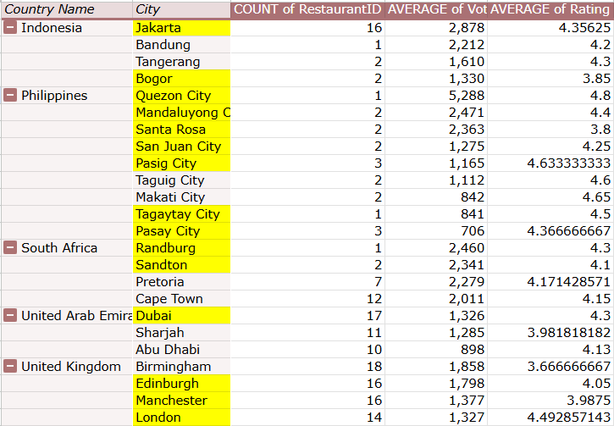

* **Approach** 
  + A pivot table was created with (**Image 5**):
    - Country and City in rows
    - Count of Restaurants, Avg. Votes and Avg. Rating in values
    - Filter by Votes>100 to maintain data quality for decision making
    - Filter by countries to only display the details of the selected 5 countries
    - Order by Average of Votes in descending order inorder to look at the engagement
  + The selection focused on cities with:
    - **Moderate number of restaurants** (to avoid saturated markets)
    - **High average vote counts** (indicating strong engagement)
    - **High average ratings** (indicating customer satisfaction and brand receptiveness)
  + Now cities with high avg. ratings denote an appreciative market where customers are supportive and value the offerings, making it an obvious selection. And cities with low avg. ratings can be either due to a non supportive market or due to the fact that the offerings provided in those cities are actually not up to the mark, clearly an opportunity for disruption by providing better quality.
  + But this needs further analysis. So in the primary analysis we will be focusing on selecting the cities with high avg. ratings.
* **Insights** 
  + A total of **26 cities** from the shortlisted 5 countries were included in the dataset.
  + **Bandung (Indonesia)** and **Santa Rosa (Philippines)** were excluded as they did not have any restaurants with more than 100 votes, which limited the reliability of feedback.
  + **Tangerang** from Indonesia, **Pasig City, Pasay City, Makati City, Taguig City, San Juan City, Mandaluyong City** from Philippines, **Randburg, Johannesburg, Sandton, Inner City** from South Africa, **Dubai** from UAE and **Manchester, Edinburgh, Birmingham** from UK are shortlisted based on the criteria of moderate restaurant count, good engagement and good avg. rating.
* **Suggestions**
  + Avoid cities with insufficient vote data, like Bandung and Santa Rosa, for now, as they lack enough customer feedback to guide a confident market entry.
  + Use this city-level analysis to guide regional launch plans, ensuring that the expansion is not only country-focused but hyper-targeted to high-performing urban centers.
  + Monitor cities with lower ratings but moderate votes for future disruption opportunities, especially where existing options may be failing to meet customer expectations.

1. According to the countries you suggested, what is the current quality regarding ratings for restaurants that are open there?

***Answer***

* **Reference**
  + **Image 6** - Pivot table representing country wise avg. rating and median rating for the shortlisted countries

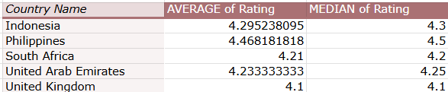

* **Approach** 
  + The dataset was filtered to include only restaurants from the five shortlisted countries identified in Q1.
  + To ensure rating accuracy, restaurants with Votes = 0 were excluded, as these typically carry default ratings and do not reflect actual customer feedback.
  + From the filtered dataset, Average Rating and Median Rating were calculated for each country to evaluate the overall quality perception from customers(**Image 6**).
* **Insights** 
  + All five shortlisted countries showed consistently high average and median ratings, typically ranging between 4.0 and 4.5, indicating strong customer satisfaction.
  + The exclusion of zero-vote restaurants helped provide a more accurate view of active and reviewed listings, ensuring the ratings were based on real engagement.
  + The small gap between average and median ratings in most countries further suggested balanced and genuine customer feedback, without extreme outliers skewing the results.
* **Suggestions**
  + Leverage these high average ratings as a confidence indicator for expansion, as they reflect strong customer satisfaction and receptiveness in the shortlisted regions.
  + Use positive customer sentiment in these countries as a basis for marketing narratives or brand positioning in new restaurants.
  + Continue tracking average and median ratings during and after entry to ensure consistent service quality and customer satisfaction benchmarks.

1. Also, what is the current expenditure on food in the suggested countries, so we can keep our financial expenditure in control?

***Answer***

* **Reference**
  + **Image 7** - Currency Exchange Rates matrix for 2010 to 2018

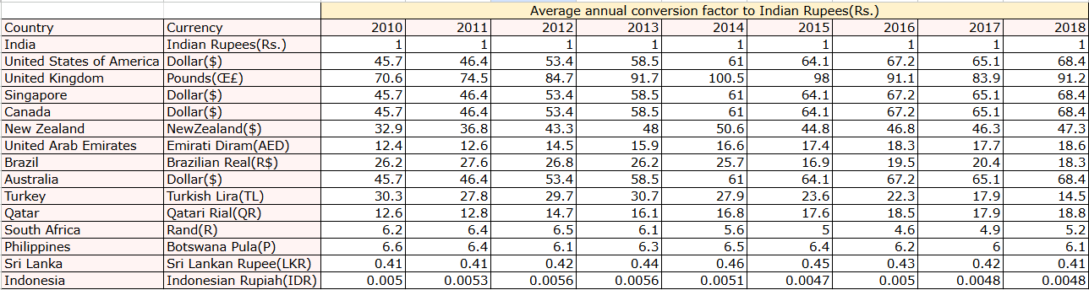

* + **Image 8** - Pivot table representing country wise currency and avg. cost for two in Indian Rupees(Rs.) or INR.

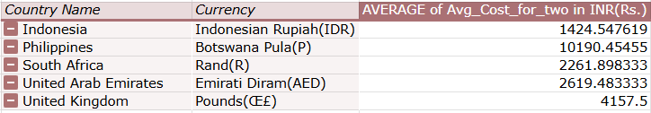

* **Approach** 
  + The dataset was filtered to include only the five shortlisted countries from Question 1: Indonesia, Philippines, United Kingdom, South Africa, and UAE.
  + To ensure meaningful comparison, the Average_cost_for_two column, originally in local currencies, was scaled to INR based on the year it opened, providing a much more accurate basis for financial comparison.
  + A historical currency-to-INR conversion matrix (2010–2018) was created(**Image 7**) using yearly average rates.
  + A formula using INDEX-MATCH was applied to retrieve the appropriate exchange rate based on each restaurant's country and year of opening.
  + This standardized cost was stored in a new column Avg_cost_for_two in INR.
  + A pivot table was then used to compute the average food expenditure in INR for each country(**Image 8**).
* **Insights** 
  + The Philippines shows the highest average cost for two at ₹10,190, which is unusually high and may be influenced by data inconsistencies or luxury dining skew. It signals a need to reassess affordability and pricing expectations.
  + The United Kingdom follows next with an average of ₹4,157, reflecting its developed market and higher cost of living.
  + United Arab Emirates and South Africa have moderate pricing, averaging ₹2,619 and ₹2,261 respectively, making them feasible markets for both mid-tier and premium formats.
  + Indonesia is the most affordable among the group, with an average spend of ₹1,424, indicating potential for a high-volume, value-based restaurant model.
  + These cost figures offer a valuable lens to understand local affordability and pricing sensitivity, helping fine-tune entry-level offerings per region.
* **Suggestions**
  + In Indonesia, consider launching affordable, value-driven concepts with high table turnover and efficient service to align with local pricing expectations.
  + In South Africa and UAE, position new restaurants at a mid-premium price point, ensuring quality justifies price while maintaining accessibility.
  + For the United Kingdom, adopt a premium pricing strategy but complement it with strong branding to meet higher customer expectations.
  + For the Philippines target high-income urban areas with luxury offerings, else recalibrate pricing models based on more refined segments.

1. Come up with the names of restaurants from the recommended states that are our biggest competitors and also those that are rated in the lower brackets, i.e. 1-2 or 2-3.

***Answer***

* **Reference**
  + **Image 9** - Pivot table representing the biggest and poorly rated restaurants from the shortlisted cities

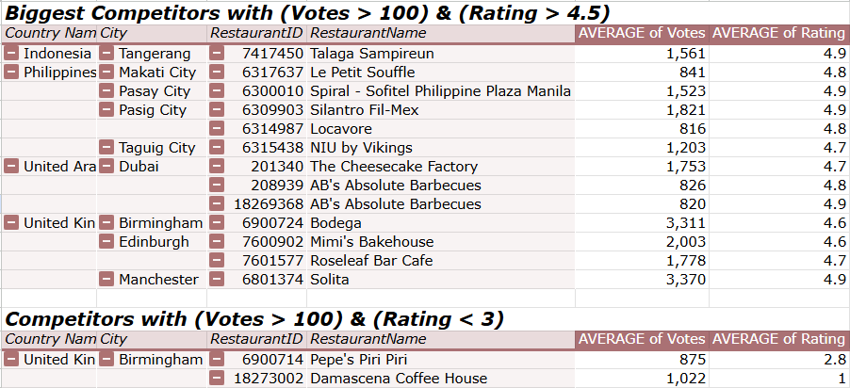

* **Approach**
  + The restaurant dataset was filtered to include only those located in the shortlisted cities from Question 2.
  + 2 pivot tables were created with(**Image 9**):
    - Country, City, Restaurant ID and Restaurant Name in rows
    - Votes and Rating in values
    - Filtered by countries and cities to only display the details of the shortlisted cities
    - Filtered by votes > 100 and rating > 4.5 in Pivot table 1 for identifying the biggest competitors. These represent the most engaged and highly rated players in their markets.
    - Filtered by rating < 3 in Pivot table 2 signaling poor customer satisfaction and potential gaps in service, food, or value.
* **Insights** 
  + In Indonesia, *Talaga Sampireun* in Tangerang stands out with 1,561 votes and an excellent average rating of 4.9, making it a strong benchmark in that city.
  + The Philippines has multiple high-performing restaurants, including *Le Petit Souffle* in Makati City and *Spiral – Sofitel Philippine Plaza Manila* in Pasay City, both maintaining ratings of 4.8–4.9 and significant vote volumes above 800. *Silantro Fil-Mex* and *Locavore* in Pasig City also show strong market acceptance.
  + In the UAE, *The Cheesecake Factory* in Dubai is a standout with 1,753 votes and a 4.7 rating, along with *AB's Absolute Barbecues*, which has two high-rated outlets (both 4.8) with significant engagement.  
    In the United Kingdom, *Bodega*, *Mimi’s Bakehouse*, *Roseleaf Bar Cafe*, and *Solita* show solid performance with ratings of 4.6 to 4.9 and vote counts exceeding 1,700–3,300 — marking them as major competitors.
  + On the flip side, Pepe’s Piri Piri and *Damascena Coffee House* in Birmingham have ratings below 3.0, despite having over 800 and 1,000 votes respectively, revealing significant customer dissatisfaction and a possible gap in quality or service.
* **Suggestions**
  + In cities like Tangerang, Makati, Pasay, and Dubai, where highly rated restaurants already exist, any new restaurant must match or exceed service quality and menu offerings to gain traction. Differentiation through unique cuisine combinations, faster service, or digital convenience could create competitive advantage.
  + In cities like Birmingham, the presence of poorly rated but widely reviewed restaurants like *Pepe’s Piri Piri* and *Damascena Coffee House* indicates a clear disruption opportunity. A new brand offering superior service, taste, and consistency can quickly win over disappointed customers.

1. Which cuisines should we focus on in the newer restaurants to get better feedback? Does the choice of cuisines affect the restaurant ratings?

***Answer***

* **Reference**
  + **Sheet 12** - Pivot table representing country wise cuisines and their rating(Table is too large, hence a snippet of the table is attached below. The table is present in Sheet 12. Sub6 in the spreadsheet)

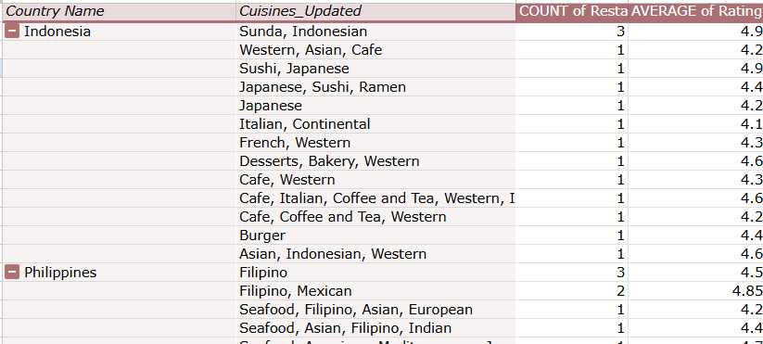

* + **Image 10** - Pivot Table representing Cuisine count(no. Of cuisines offered) vs. the count of restaurants and avg. rating for all countries.

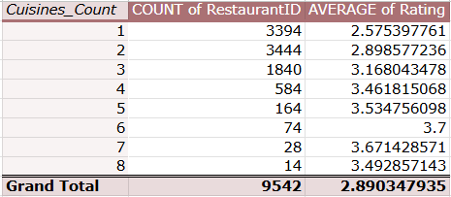

* + **Image 11** - Pivot Table representing Cuisine count(no. Of cuisines offered) vs. the count of restaurants and avg. rating for top 5 countries.

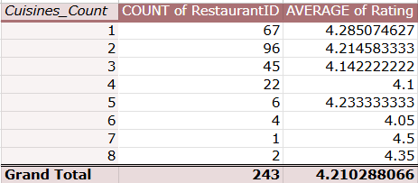

* **Approach** 
  + The analysis began by grouping restaurants based on the type of cuisine offered. A pivot table was created to display the average rating per cuisine across the shortlisted 5 countries(as shown in **Sheet 12 of the workbook**).
  + To ensure quality, cuisines with top rating of greater than 4 were included.
  + To understand the impact of variety, a new column named Cusine_count was used to track the number of cuisines offered by each restaurant.
  + Average ratings were then analyzed across different cuisine count ranges to determine the optimal variety(**Image 10**).
  + This analysis was also repeated separately for the five shortlisted countries (Indonesia, Philippines, South Africa, UAE, UK) to check for consistency in trends(**Image 11)**.
* **Insights** 
  + 'Sunda, Indonesian', 'Filipino', 'Mexican', 'Indian' and 'Italian’ turned out to be the most frequented cuisines in countries Indonesia, Philippines, South Africa, UAE, UK respectively and these cuisines turned out to be well-rated as well.
  + Moreover, the number of cuisines offered seem to play a key role here. They tend to form a positive correlation. Cuisine count of 6 seems to be the best rated.
  + Restaurants that offered 4 to 6 cuisines had the highest average ratings, suggesting that a moderate variety appeals to customers more than overly focused or overly broad menus.
  + In the five shortlisted countries, while top-rated cuisines remained consistent, restaurants offering more than four cuisines were relatively rare, indicating an opportunity to fill that gap.
  + A mix of globally loved cuisines and region-specific favorites appears to create the most favorable perception among diners.
* **Suggestions**
  + Design menus with 4–6 curated cuisines to balance diversity and focus, maximizing customer satisfaction without overwhelming the kitchen or diners.
  + Avoid excessive menu diversification — especially offering more than 6 cuisines, unless it's part of a large-format or buffet-style concept.
  + Introduce underrepresented but highly rated cuisines in new markets, which can become a competitive differentiator.

1. According to our current data, should we go for online delivery and table booking? Does that affect the customer’s ratings?

***Answer***

* **Reference**
  + **Image 12** - Restaurants rated on the basis of offerings Table_booking and Online_delivery

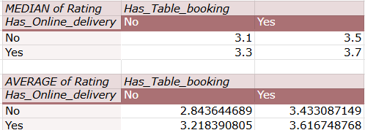

* **Approach** 
  + A two-dimensional pivot table was constructed with has_online_delivery and has_table_booking placed in rows and columns(**Image 12**).
  + The Average Rating and Median Rating were calculated for all four combinations of these features.
  + This helped isolate the effect of each feature independently and in combination on customer satisfaction.
  + To ensure data quality, only restaurants with non-zero votes were considered, eliminating skew from default ratings. This allowed for a more accurate assessment of how availability of service features correlates with customer satisfaction.
* **Insights** 
  + Restaurants offering neither online delivery nor table booking had the lowest average rating and median rating.
  + Restaurants that offered one of the services had significantly improved ratings.
  + Restaurants that offered both services had the highest ratings, with an average of 3.61 and median of 3.7, clearly outperforming all other groups.  
    This suggests that the presence of these features directly correlates with improved customer feedback.
* **Suggestions**
  + Both online delivery and table booking should be enabled for all new restaurant launches, as the combination yields the highest customer satisfaction scores.
  + If operational constraints exist, prioritize implementing at least one of the two, since even a single service improves ratings noticeably compared to having neither.
  + These features are not only expected by modern diners but also act as trust signals that enhance brand perception and visibility on platforms like Zomato.

1. Should the team keep the rate of cuisines higher? Will that affect the feedback? According to our data are the rates of cuisines and ratings, correlated?

***Answer***

* **Reference**
  + **Image 13** - Correlation Analysis
  + 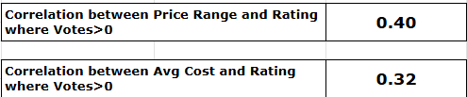
* **Approach** 
  + To evaluate whether the pricing of cuisines influences customer feedback, two correlation analyses were performed(**Image 13**):
    - Between price_range (a 1–4 scale) and rating
    - Between avg_cost_for_two in INR and rating
  + The dataset was filtered using the FILTER() function to include only entries where votes > 0, in order to remove the bias from default ratings associated with unrated restaurants.
  + The CORREL() function was used to calculate the degree of linear association between pricing and feedback quality.
  + Function used is as follows:
    - =CORREL(FILTER(avg_cost_for_two in INR, votes>0),FILTER(rating, votes>0))
    - =CORREL(FILTER(price_range, votes>0),FILTER(rating, votes>0))
    - Note that in the functions listed above the column names as used directly for readability and understandin
* **Insights** 
  + A moderate positive correlation of 0.40 was found between Price Range and Rating, indicating that restaurants in higher pricing tiers tend to receive better customer ratings.
  + A weaker but still noticeable correlation of 0.32 was observed between Average Cost (INR) and Rating, suggesting that higher actual cost can also contribute positively to customer perception — although not as strongly as relative price tiering.
  + This indicates that perceived value within a price category (e.g., mid-range vs. premium) plays a bigger role in influencing satisfaction than the absolute amount spent.
  + The findings confirm that customers are generally willing to pay more, but expect quality, ambiance, and service consistency in return.
* **Suggestions**
  + New restaurants should be strategically positioned in the moderate-to-premium pricing tiers (Price Range 3–4) to benefit from the stronger correlation with positive ratings.
  + Avoid underpricing (Price Range 1–2) unless the offering clearly targets a value-driven market segment with limited expectations.
  + Highlight value propositions and the offerings to justify higher price points and attract higher ratings.

1. What is the distribution of the number of restaurants of different price ranges in all the countries?

***Answer***

* **Reference**
  + **Image 14** - Pie chart demonstrating distribution of restaurants based on price range

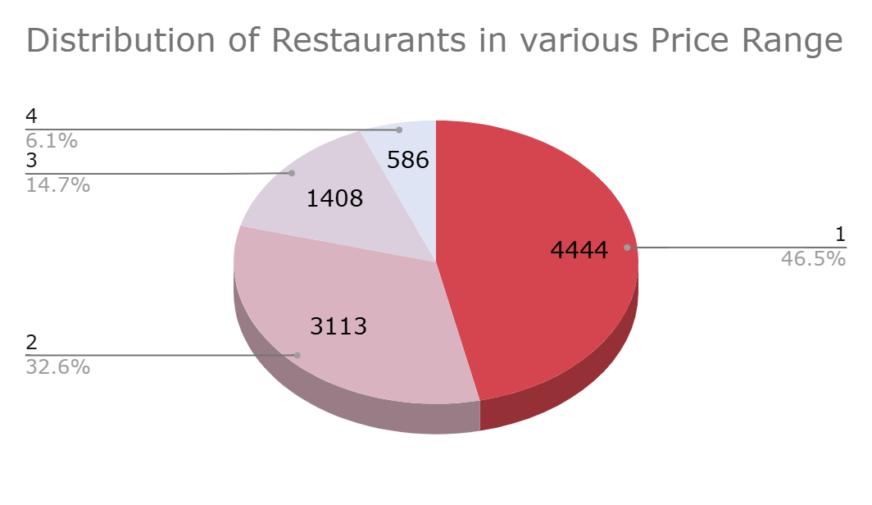

* **Approach** 
  + A pivot table was created with price_range (values 1 to 4) in rows and the count of restaurants in values.
  + The data was then visualized using a pie chart to clearly display the proportion of restaurants operating under each price category(**Image 14**).
  + This analysis was done on the complete dataset to understand the overall pricing strategy used by restaurants across all countries.
* **Insights** 
  + Price Range 1 dominates the dataset, accounting for 46.5% (4,444 restaurants), indicating a heavy tilt toward budget or low-priced offerings.
  + Price Range 2 includes 3,113 restaurants (32.6%), suggesting a strong presence of mid-tier establishments.
  + Price Range 3 represents 14.7% (1,408 restaurants), and Price Range 4 has only 586 restaurants (6.1%), showing that premium-positioned restaurants are relatively rare.
  + The dataset shows a clear skew toward lower and mid-priced models, likely driven by mass-market affordability and volume-driven business models.
* **Suggestions**
  + The current market is heavily saturated in Price Ranges 1 and 2. To stand out, our expansion strategy could focus more on Price Range 3, where competition is lower, yet ratings and customer satisfaction are higher.
  + Launching restaurants in Price Range 3–4 provides differentiation and allows for better customer perception, as these ranges are less crowded yet better rated.
  + Introduce flexible menu tiers or premium upgrades to serve both mid-market and premium customers, without fully committing to Price Range 4.

1. Explain your approach in brief for suggesting countries/cities in order to open new restaurants, if the objective and subjective questions would have not been given to assist you. **[you have to give bullet pointers in order to answer this question]**

***Answer***

* If the objective and subjective questions had not been provided, my approach to identifying suitable countries and cities for restaurant expansion would begin in a similar way by cleaning the data and validating the quality of it.
* Then I would start with analyzing the basic distribution of restaurants across regions. I would first use pivot tables and charts to evaluate the number of restaurants in each country and city, identifying underrepresented locations with potential for growth.
* To ensure the analysis is grounded in meaningful customer interaction, I would apply filters to focus only on restaurants with over a minimum threshold of votes thereby eliminating noise from under-reviewed listings.
* Next, I would assess customer satisfaction by analyzing both average and median ratings and votes. This would help determine not just the overall sentiment, but also whether engagement in a market is consistent or skewed.
* Based on these factors I would try to develop a scoring criteria. Thus I would segment all countries using data-backed thresholds based on restaurant count, vote quality, and customer ratings categorizing them into various buckets.
* Additionally, I would leverage time-based data using the year column to uncover growth trends and emerging hotspots.
* Next other attributes like cuisine count, price range, avg cost would be incorporated to understand qualitative dimensions of customer experience and restaurant diversity.
* I would then validate feasibility by checking correlations between the various features ensuring that strategic recommendations are aligned with measurable market demand.
* Finally I would shortlist all the essential and important pivot tables and charts and collate them to a dashboard to facilitate easy readability and understanding of the data.

**Dashboard**

Finally all the findings and insights have been accommodated into the dashboard. Attaching the screenshot of the dashboard developed.

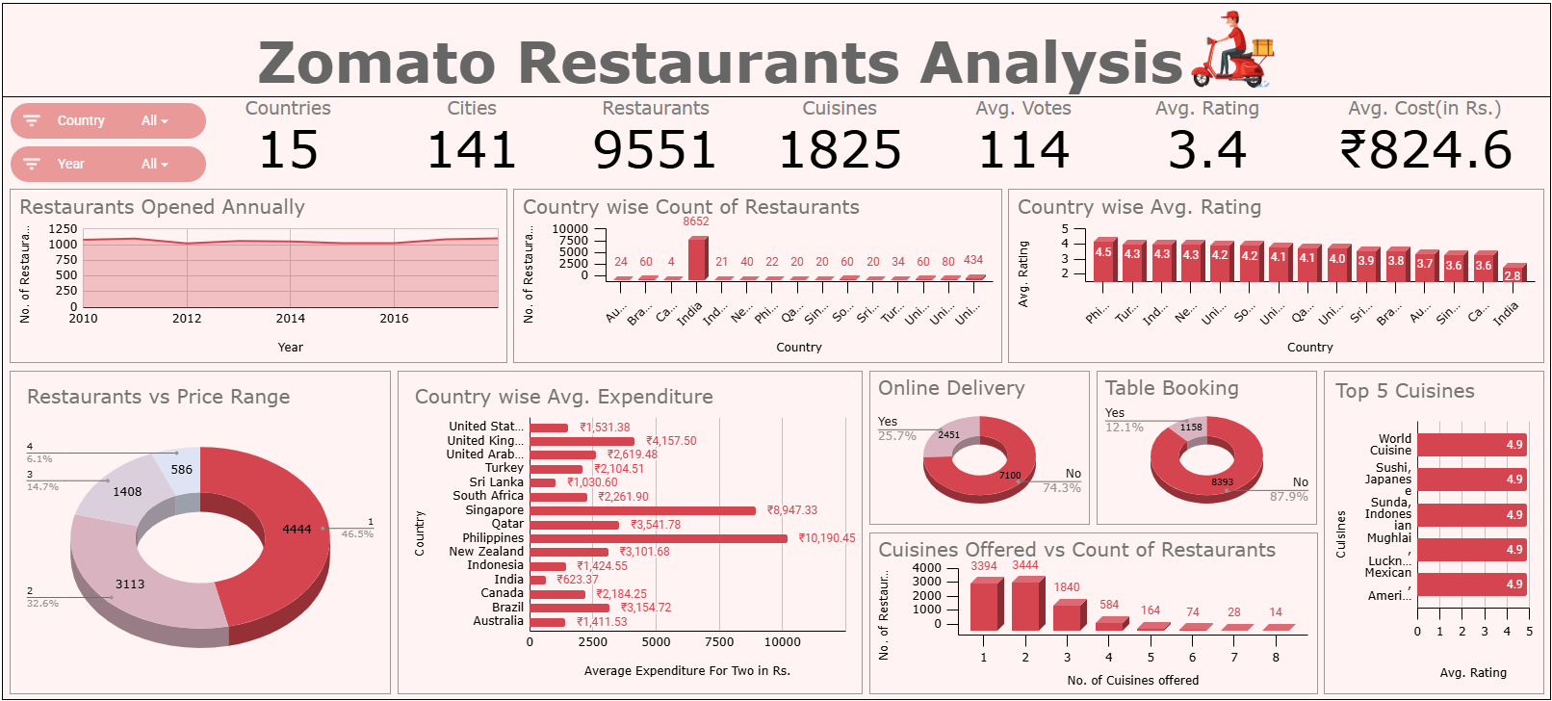

1. The dashboard gives a data summary of:
   * No. of countries
   * No. of restaurants
   * No. of cities
   * No. of cuisines
   * Avg. votes
   * Avg. rating
   * Avg. cost in Rs.
2. The charts included are:
   * Pie charts showing distribution of restaurants:
     + In various price ranges
     + Offering table booking
     + Offering online delivery
   * Area chart showing the no. of restaurants opened in each year
   * Column chart showing:
     + Top five cuisines based on avg. rating
     + Country wise avg. expenditure in Rs.
   * 3D Bar chart showing:
     + No. of restaurants providing different no. of cuisines
     + Country wise avg. rating
     + Country wise count of retaurants
3. Various slicers are also added for easy usability of the dashboard. They are:
   * Country
   * Year